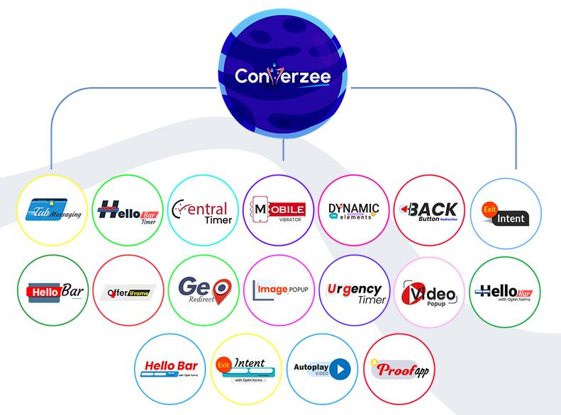**Everything You Need to Engage and Convert Visitors into Enrolment Inside One Easy to Use Platform!**

Profile Listing

School Video Tour

The 21st Century School Marketing System

Web Optimization

Leads Score Improvement

Enrolment Increase

Ranking Factor Improvement

Review Rating Improvement

Community As Marketing Force

Prospect Generation

Brand Awareness

GMP Optimization

Market Place Access

Key Words Search Listing

YouTube Marketing

Digital Marketing

Proof-it- Marketing

Referral Marketing

Bait Marketing

# Schools Have TRIPLED Their Leads & Enrolments Using The 21st Century School Marketing Platform!!

# EIGHTEEN Most Powerful Growth Hacking Optimization & Enrolment Improvement Tools Packed into A SINGLE Platform

### Helps you get 330% More Leads & Enrolments and Improve Brand Visibility by 50-86%!!



# The 21st Century School Marketing Platform is a Collection of 18 Brand Visibility Improvement, Lead Generating and Enrolment Increase Software Packed Into 1

# Let me show you some of the tools that are included inside the Platform:

# 

## Schools can celebrate their achievements, offer scholarship as a bait for enrolment and enlist the entire community as their marketing force.

## 

## Parents can find a school for their children, take video tour of schools, view schools’ documentary of achievements, create admission profile, complete admission form, pay for registration form, check for admission test date, check test result and print off admission letter.



## Young Nigerians can refer enrolment to schools through a referral link in exchange for referral commission published by the school as an amount they are ready pay-out for each referral that turn into enrolment.



## The school click-through advert banner listed as a tile on the home page. This takes parents to the school page where all the school marketable information such as school profile, video tour etc are listed.



## Intending parents can create enrolment account, complete the enrolment form, check the date of their enrolment test and check their test result.

## The school will be able to publish how much the school is willing to pay as commission for each enrolment referred by a referral. The referral can forward prospects to the school through the online referral link or form.





## The school will be able to add testimonies and a documentary of the school landmark achievements to the page.



## The school will have access to analytics and insight reports and have ability to publish scholarship offer...

## Celebrate your school achievements on Learnnova YouTube channel and also use the channel to promote your offer and brand.



PRICE: ~~N249, 950.00~~ SAVE 48% N129,950.00 per term



Buy Membership Bundle